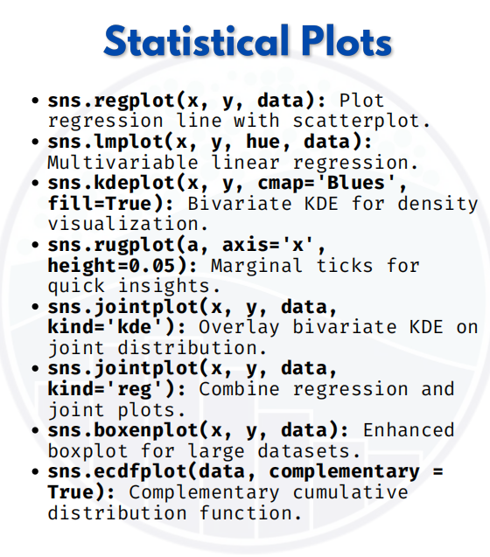

Statistical plot

A simple student dataset:
import seaborn as sns
import matplotlib.pyplot as plt
import pandas as pd

# Sample dataset
data = pd.DataFrame({
"Maths": [45, 67, 78, 56, 89, 92, 58, 76, 88, 95],
"Science": [40, 65, 80, 55, 86, 90, 60, 74, 85, 97],
"Gender": ["M","F","M","F","M","M","F","M","F","M"]
})

1. Regression Plot (sns.regplot)
Scatterplot + regression line
sns.regplot(x="Maths", y="Science", data=data)
plt.show()

2. Linear Model Plot (sns.lmplot)
Scatterplot + regression line with grouping (hue)
sns.lmplot(x="Maths", y="Science", hue="Gender", data=data)
plt.show()
3. KDE Plot (sns.kdeplot)
Density visualization (bivariate)
sns.kdeplot(x="Maths", y="Science", data=data, cmap="Blues", fill=True)
plt.show()

4. Rug Plot (sns.rugplot)
Small ticks along the axis
sns.rugplot(x=data["Maths"], height=0.05)
plt.show()

5. Joint Plot (KDE)
Joint distribution + KDE
sns.jointplot(x="Maths", y="Science", data=data, kind="kde")
plt.show()

6. Joint Plot (Regression)
Joint distribution + regression line
sns.jointplot(x="Maths", y="Science", data=data, kind="reg")
plt.show()

7. Boxen Plot (sns.boxenplot)
Enhanced boxplot for large datasets
sns.boxenplot(x="Gender", y="Maths", data=data)
plt.show()
8. ECDF Plot (sns.ecdfplot)
Cumulative distribution function
sns.ecdfplot(data["Maths"], complementary=True)
plt.show()

